CS 323_33 Programming Language: C++

Project #8 K-means Clustering

Andres Quintero

Due Date:

Soft copy: 4/5/2020

Hard copy: 4/5/2020

*******************************************Main*********************************************

Step 0: pointSet 🡨 given, K 🡨 given

changes 🡨 0

Step 1: randomly select k points from pointSet.

(The selected k points will be the initial K centroids.)

Step 2: For each point, p, in pointSet, compute distance from p to each centroid

(K of them). So, we have K distances: d1, d2,..., dk, associate with each di is the label of the centroid.

Step 3: minLabel 🡨 the label of min(d2,..., dk)

Step 4: if p’s label != minLabel

P’s label 🡨 minLabel

changes ++

Step 5: repeat step 2 to step 4 until all points in pointSet are processed

Step 6: if changes > 2

Compute centroid for each group,...

changes 🡨 0

Step 7: repeat step 2 to step 6 until changeFlag <= 2

**SOURCE CODE:**

#include <iostream>

#include <string>

#include <fstream>

#include <cstdlib>

#include <cmath>

using namespace std;

// Data structures

class Point{

public:

double Xcoord;

double Ycoord;

int Label = 0;

double Distance = 99999.00;

};

// Prototypes

void loadPointSet(ifstream& inFile, Point* pointSet);

void PlotDisplayAry(Point* pointSet, int** displayAry, int numPts);

void PrettyPrint(int** displayAry, ofstream& outFile, int iteration, int rows, int cols);

void kMeansClustering(Point* pointSet, int K, Point* KcentroidAry, int** displayAry, ofstream& outFile1, ofstream& outFile2, int numPts, int numRows, int numCols, int changes);

void selectKcentroids(Point* pointSet, int K, Point* KcentroidAry, int numPts);

int DistanceMinLabel(Point& pt, Point* KcentroidAry, double& minDist, int K);

double computeDist(Point pt, Point centroid);

void computeCentroids(Point* pointSet, Point* KcentroidAry, int K, int numPts);

void PrintResult(Point* pointSet, ofstream& outFile1, int numRows, int numCols, int numPts);

int main(int argc, char* argv[]){

ifstream inFile(argv[1]);

int K = stoi(argv[2]);

ofstream outFile1(argv[3]);

ofstream outFile2(argv[4]);

// Variables

// 1

int numRows, numCols, numPts, changes = 0;

inFile >> numRows;

inFile >> numCols;

inFile >> numPts;

int** displayAry = new int*[numRows];

for(int i = 0; i < numRows; i++){

displayAry[i] = new int[numCols];

}

Point* pointSet = new Point[numPts];

Point* KcentroidAry = new Point[K+1];

for(int i = 0; i < K+1; i++){

KcentroidAry[i].Distance = 0.0;

}

loadPointSet(inFile, pointSet);

kMeansClustering(pointSet, K, KcentroidAry, displayAry, outFile1, outFile2, numPts, numRows, numCols, changes);

PrintResult(pointSet, outFile2, numRows, numCols, numPts);

// Closing Files

inFile.close();

outFile1.close();

outFile2.close();

}

// Functions

void PrintResult(Point* pointSet, ofstream& outFile2, int numRows, int numCols, int numPts){

outFile2 << numRows << " " << numCols << endl;

outFile2 << numPts << endl;

for(int i = 0; i < numPts; i++){

outFile2 << pointSet[i].Xcoord << " " << pointSet[i].Ycoord << " " << pointSet[i].Label << endl;

}

}

void computeCentroids(Point* pointSet, Point* KcentroidAry, int K, int numPts){

double sumX[K+1];

double sumY[K+1];

int totalPt[K+1];

for(int i = 0; i < K+1; i++){

sumX[i] = 0.0;

sumY[i] = 0.0;

totalPt[i] = 0;

}

// 1

int index = 0;

int label = 0;

while(index < numPts){

//2

label = pointSet[index].Label;

sumX[label] += pointSet[index].Xcoord;

sumY[label] += pointSet[index].Ycoord;

totalPt[label]++;

// 3

index++;

} // 4

// 5

label = 1;

while(label <= K){ // <= K because we need K elements and we start label at 1

// 6

if(totalPt[label] > 0.0){

KcentroidAry[label].Xcoord = (sumX[label]/totalPt[label]);

KcentroidAry[label].Ycoord = (sumY[label]/totalPt[label]);

}

// 7

label++;

}

}

double computeDist(Point pt, Point centroid){

double result = sqrt( pow( (pt.Xcoord-centroid.Xcoord), 2) + pow( (pt.Ycoord-centroid.Ycoord), 2) );

return result;

}

int DistanceMinLabel(Point& pt, Point* KcentroidAry, double& minDist, int K){

// minDist = 99999.0;

int minLabel = 0;

int label = 1;

while (label <= K){

// Point whichCentroid = KcentroidAry[label];

double dist = computeDist(pt, KcentroidAry[label]);

if(dist < minDist){

minLabel = label;

minDist = dist;

}

label++;

}

return minLabel;

}

void selectKcentroids(Point* pointSet, int K, Point* KcentroidAry, int numPts){

// creating data structure

bool checkedPoints[numPts];

for(int i = 0; i < numPts; i++){ checkedPoints[i] = false;}

int index = rand() % numPts;

// bool repeatYN = false;

int Kcnt = 0;

while(Kcnt < K){

while(checkedPoints[index]){

index = rand() % numPts;

// repeatYN = checkedPoints[index];

}

Kcnt++;

KcentroidAry[Kcnt].Xcoord = pointSet[index].Xcoord;

KcentroidAry[Kcnt].Ycoord = pointSet[index].Ycoord;

KcentroidAry[Kcnt].Label = Kcnt;

KcentroidAry[Kcnt].Distance = 0.0;

checkedPoints[index] = true;

}

}

void kMeansClustering(Point* pointSet, int K, Point* KcentroidAry, int** displayAry, ofstream& outFile1, ofstream& outFile2, int numPts, int numRows, int numCols, int changes){

// 0

int iteration = 0;

int index = 0;

int doOnce = 1;

// 1

selectKcentroids(pointSet, K, KcentroidAry, numPts);

while (iteration < 25 || doOnce > 0) { // 2 - 9

doOnce--;

// 2

index = 0;

iteration++;

while (index < numPts){ // 4 - 7

// 4

Point pt = pointSet[index];

double minDist = pointSet[index].Distance;

// 5

int minLabel = DistanceMinLabel(pt, KcentroidAry, minDist, K);

// pointSet[index].Distance = minDist;

// 6

if(pointSet[index].Label != minLabel){

pointSet[index].Label = minLabel;

pointSet[index].Distance = minDist;

changes++;

}

// 7

index++;

} // 8 loop

// 9

if (changes > 2) {

computeCentroids(pointSet, KcentroidAry, K, numPts);

changes = 0;

}

// // 3

PlotDisplayAry(pointSet, displayAry, numPts);

PrettyPrint(displayAry, outFile1, iteration, numRows, numCols);

}// 10 loop

}

void PrettyPrint(int** displayAry, ofstream& outFile1, int iteration, int rows, int cols){

outFile1 << "\t*************** Result of iteration " << iteration << " ***************" << endl;

for(int i = 0; i < rows; i++){

for(int j = 0; j < cols; j++){

if(displayAry[i][j] > 0 ){

outFile1 << displayAry[i][j];

} else {

outFile1 << " ";

}

}

outFile1 << endl;

}

}

void PlotDisplayAry(Point* pointSet, int** displayAry, int numPts){

// X is the row

// Y is the col

for(int i = 0 ; i < numPts; i++){

displayAry

[(int) pointSet[i].Xcoord]

[(int) pointSet[i].Ycoord] = pointSet[i].Label;

}

}

void loadPointSet(ifstream& inFile, Point* pointSet){

int index = 0;

int x,y;

while(!inFile.eof()){

inFile >> x;

inFile >> y;

pointSet[index].Xcoord = (double) x;

pointSet[index].Ycoord = (double) y;

pointSet[index].Label = 0;

pointSet[index].Distance = 99999.0;

index++;

}

}

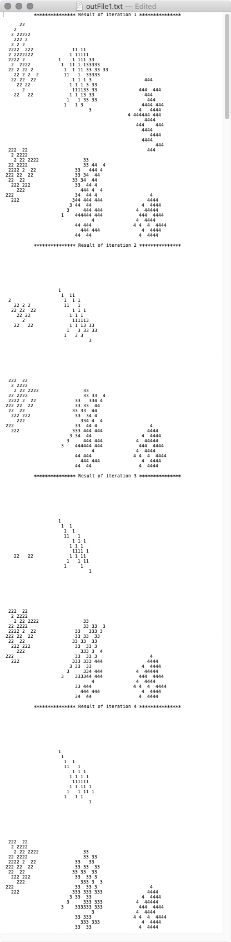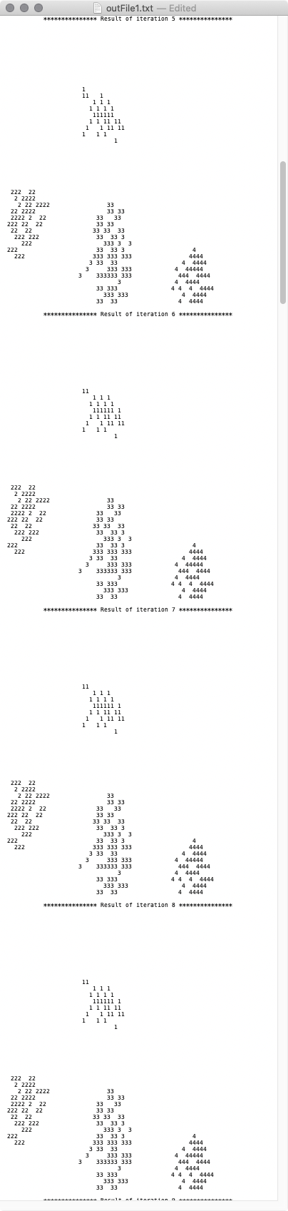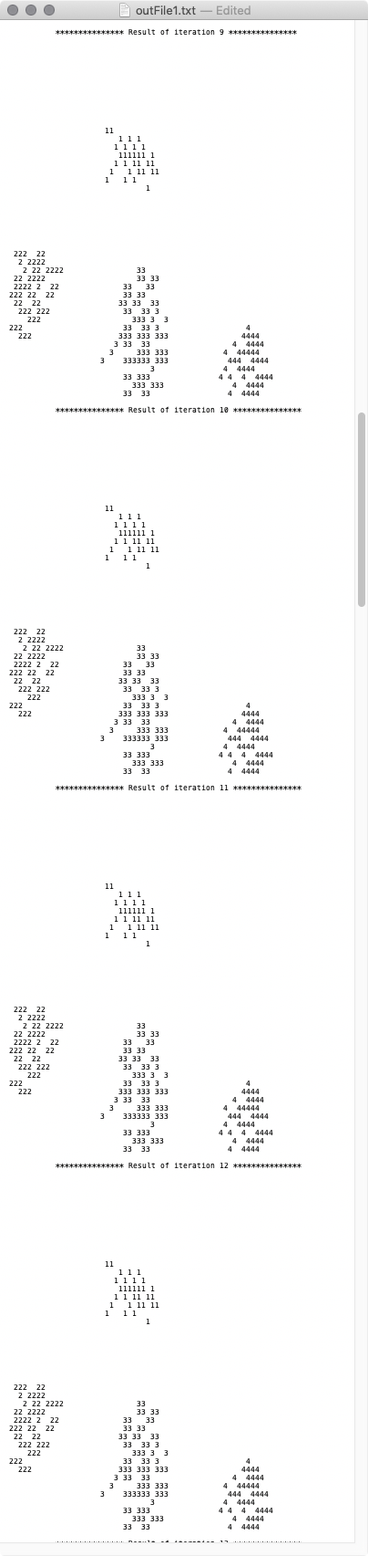

K =4

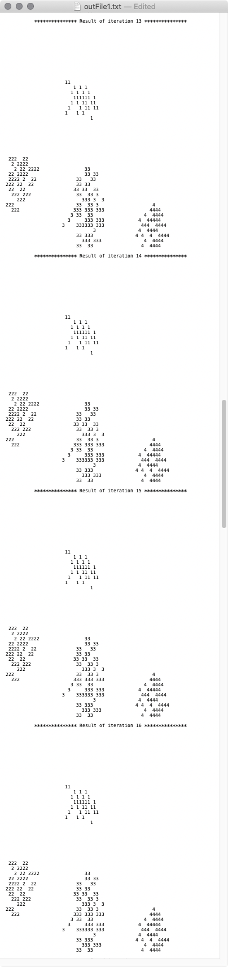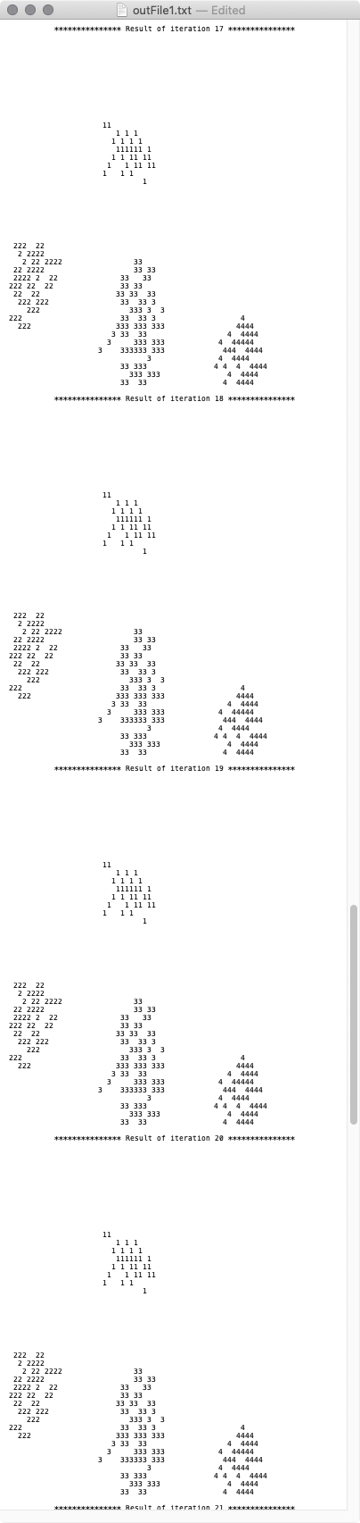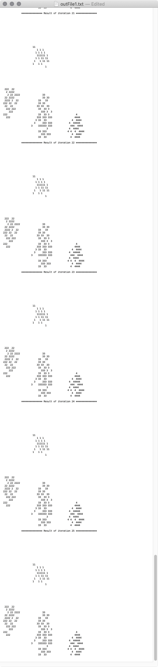

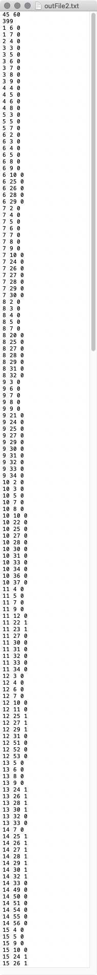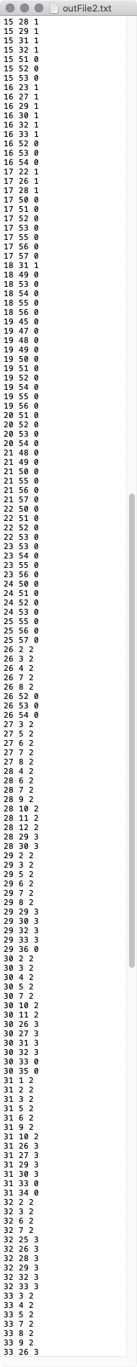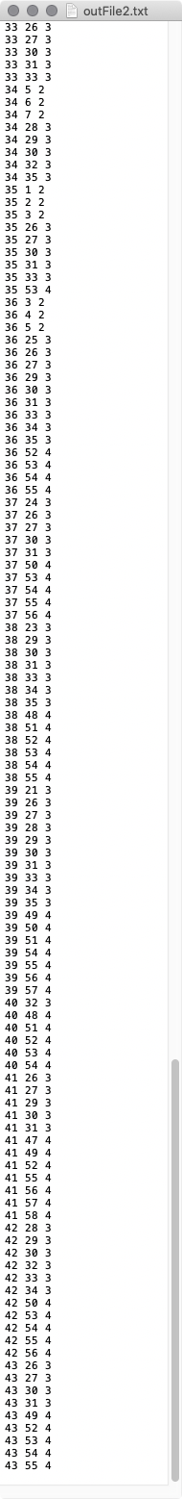 END OF K = 4

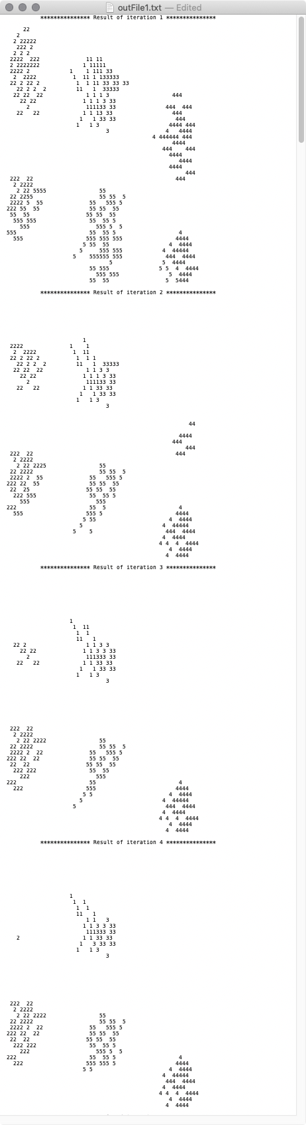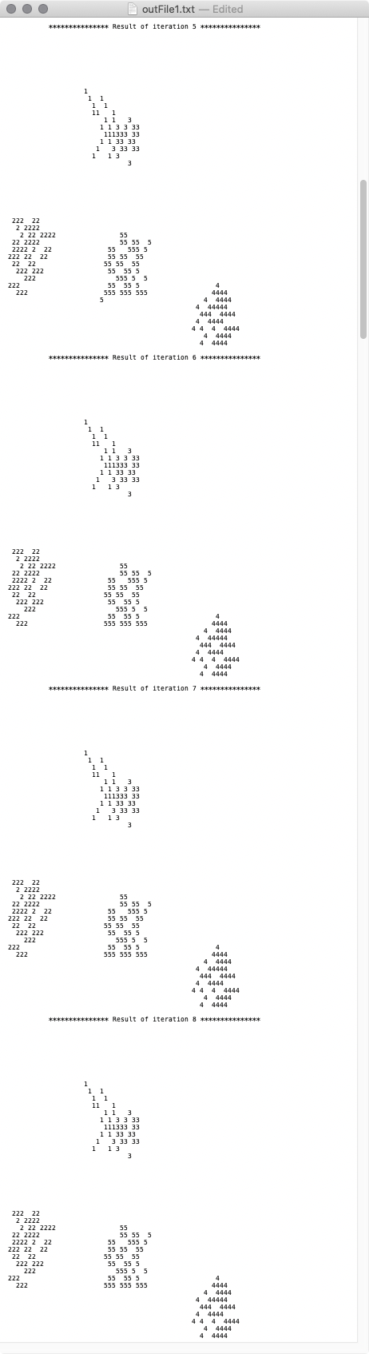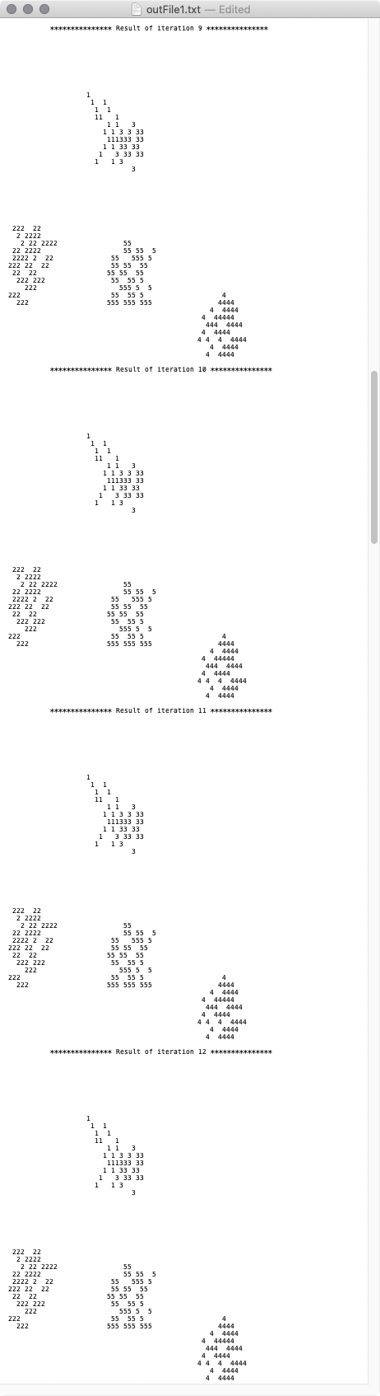

K = 5

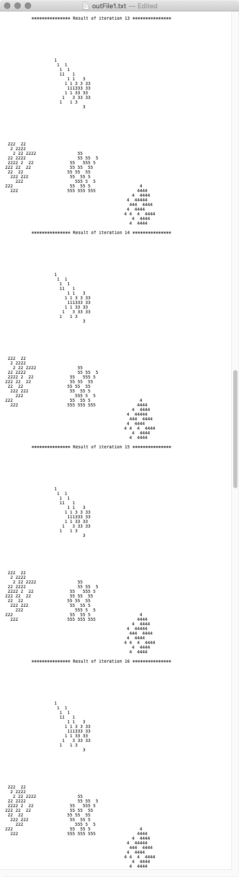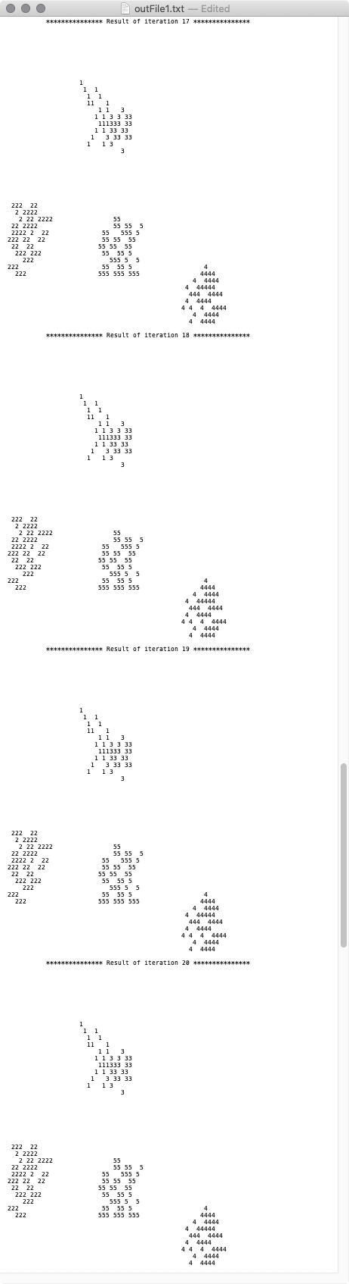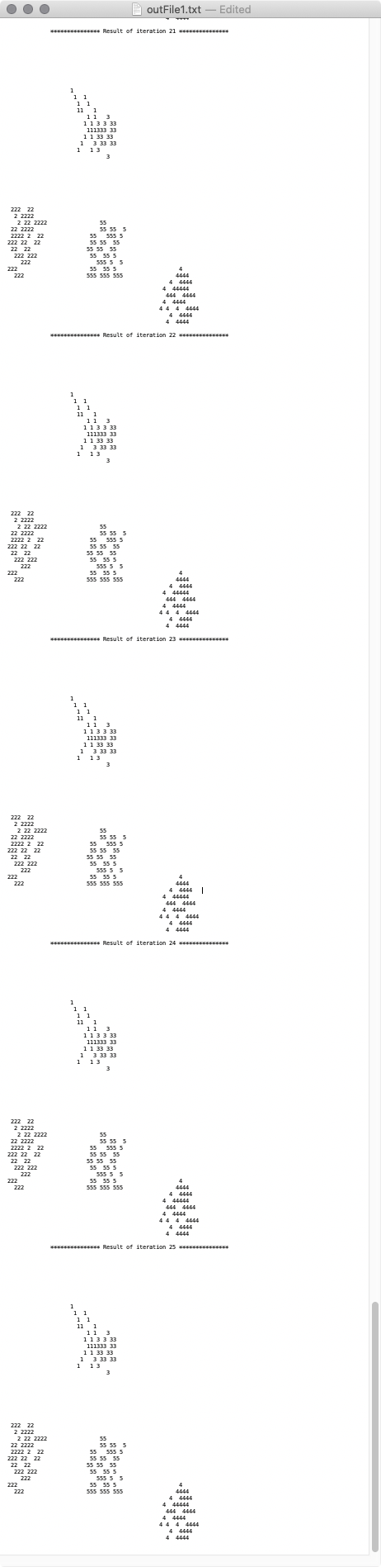

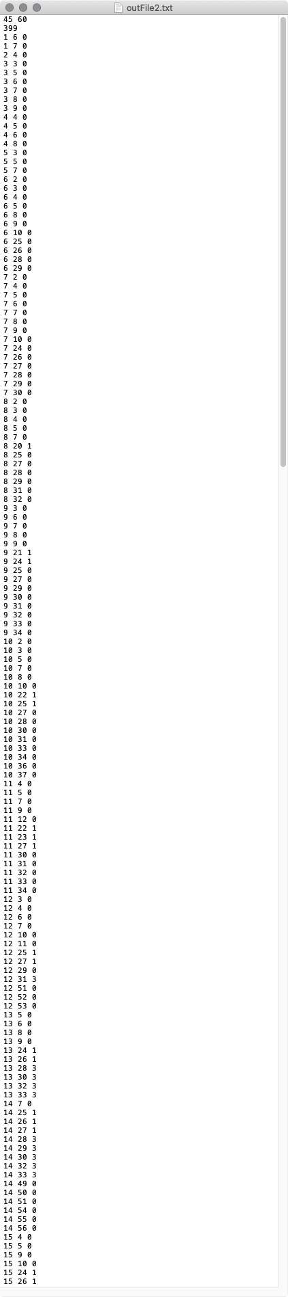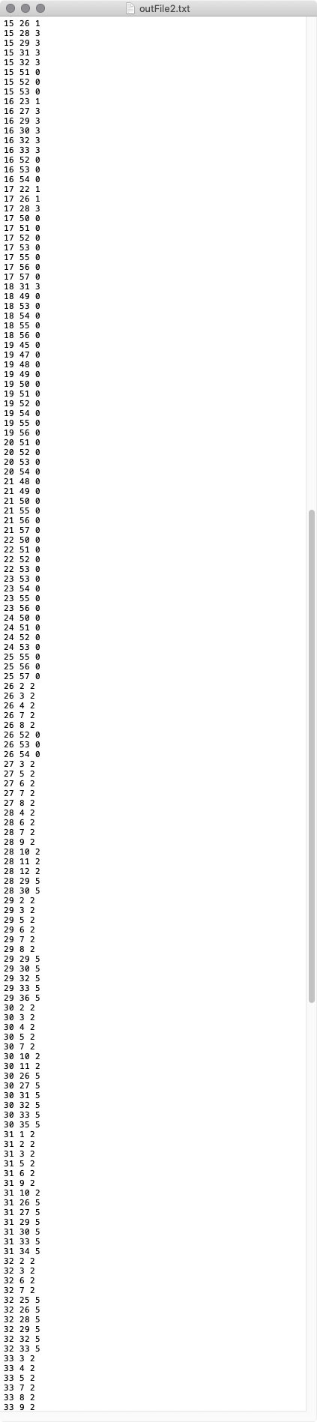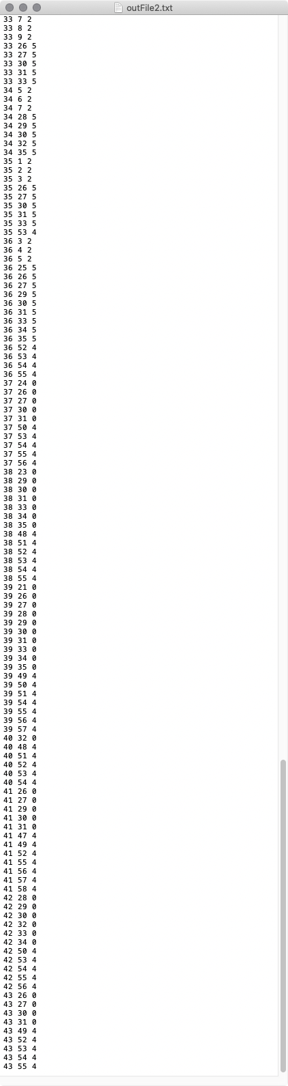

End of K = 5

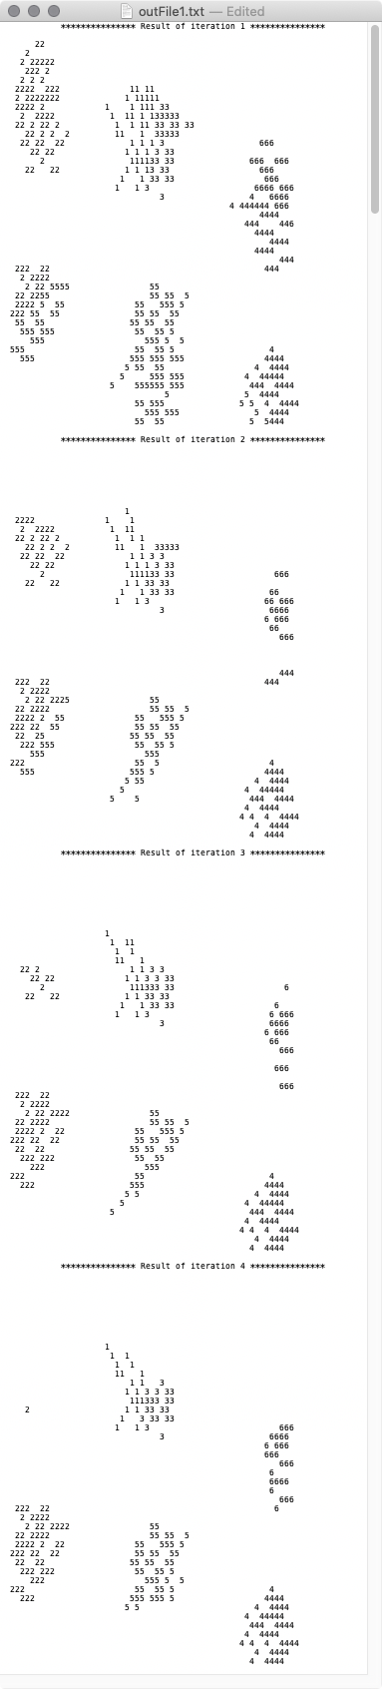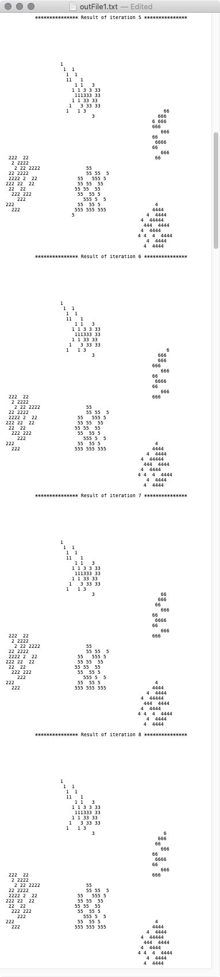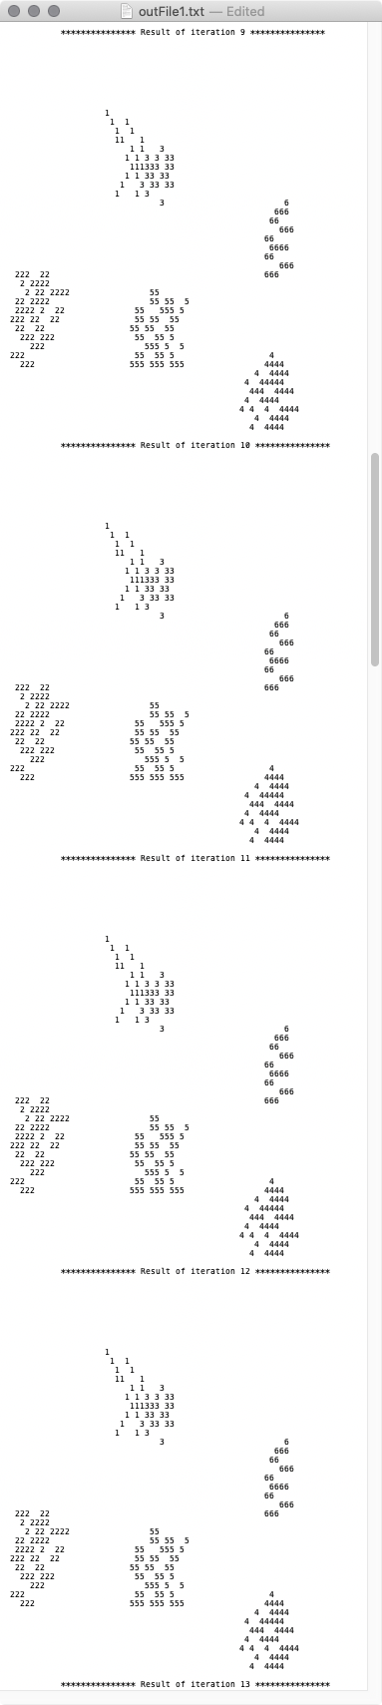

K = 6

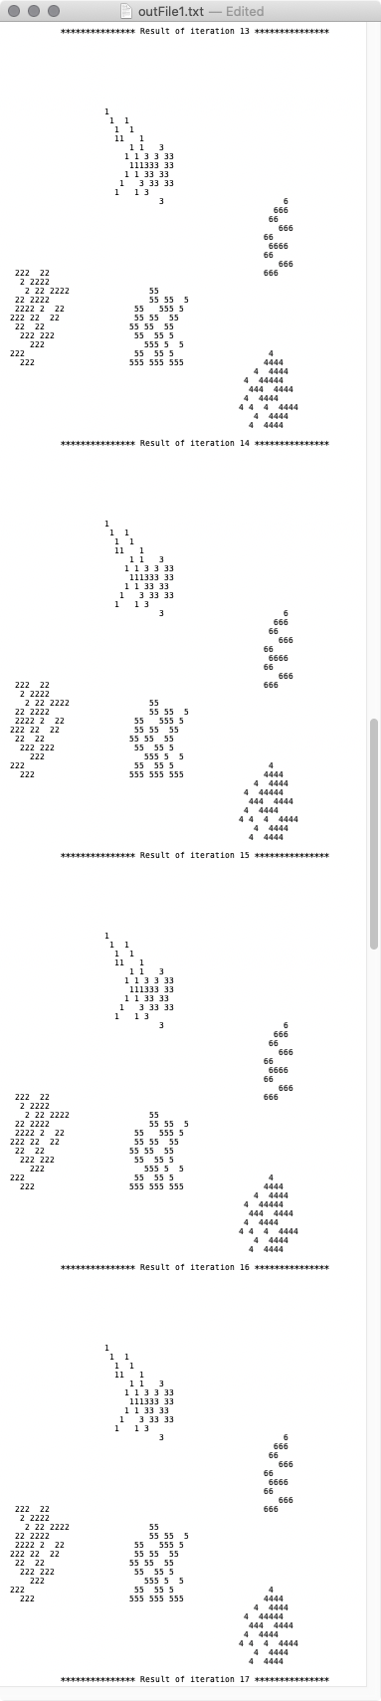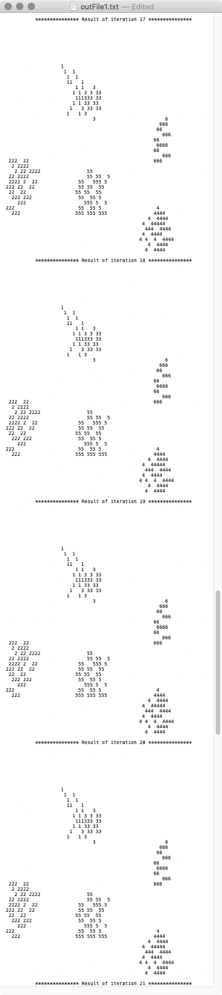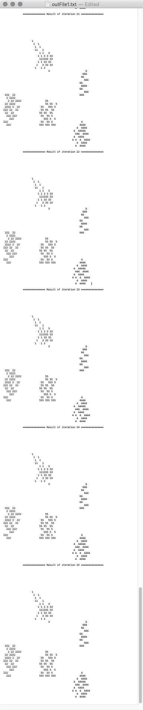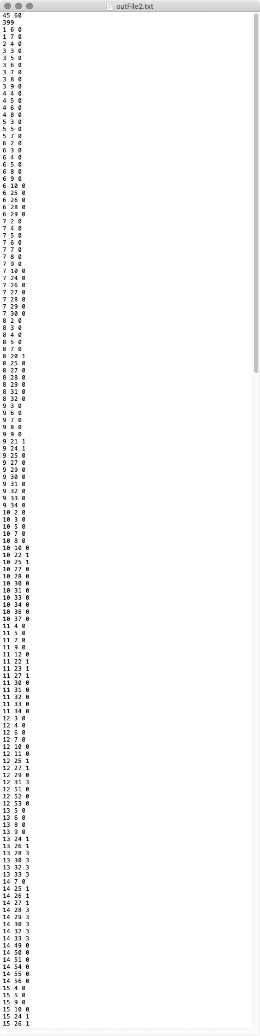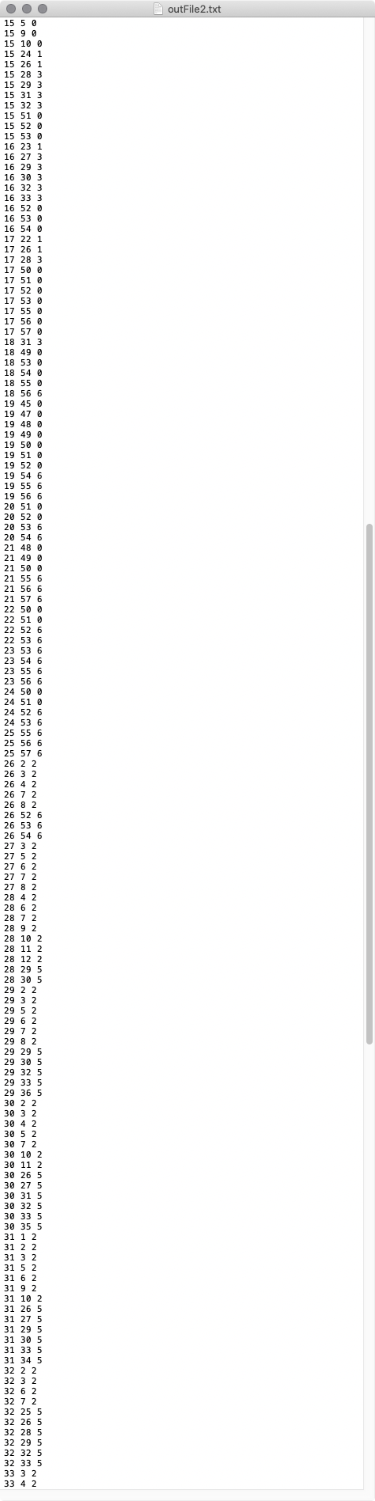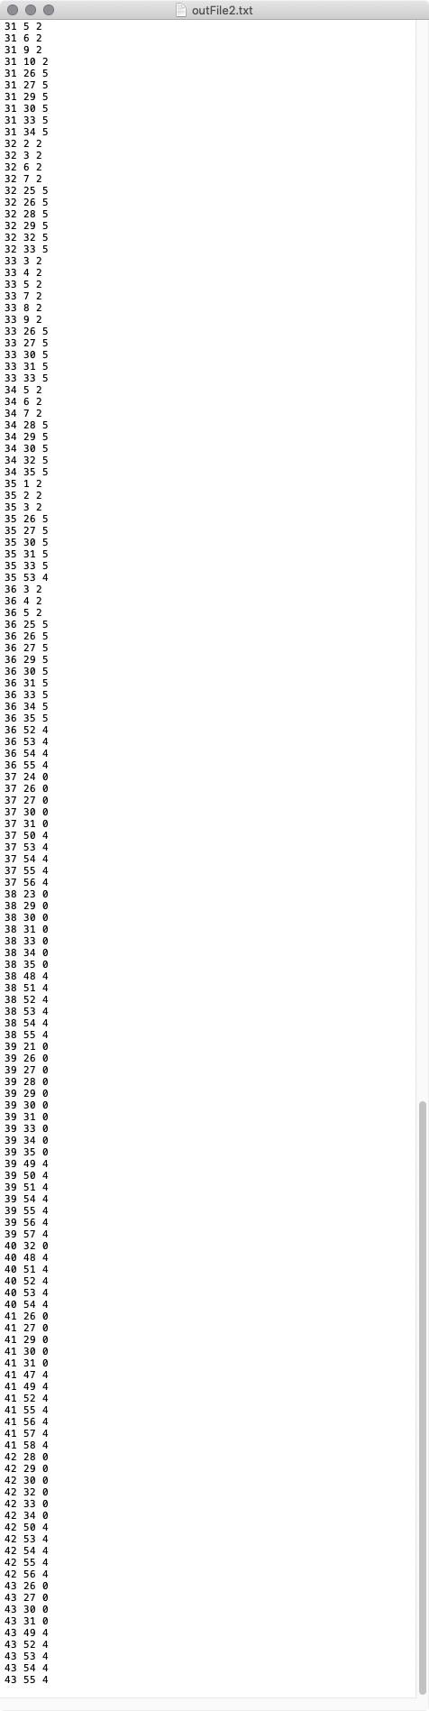

END OF K = 6

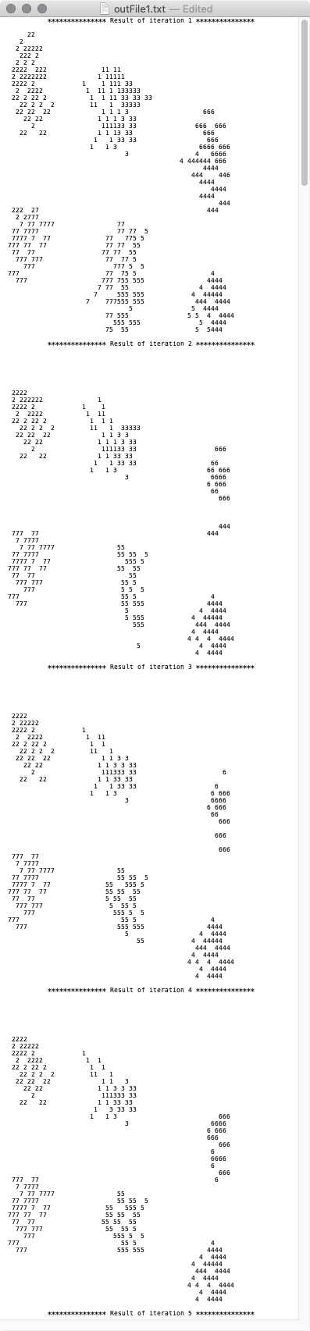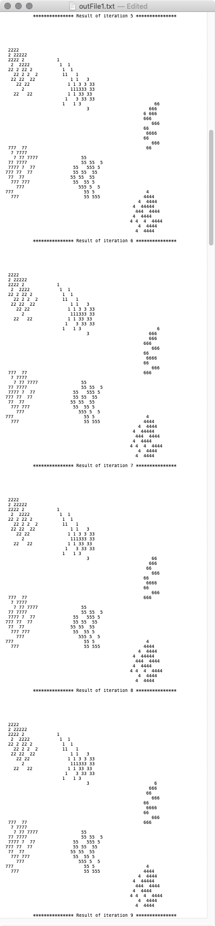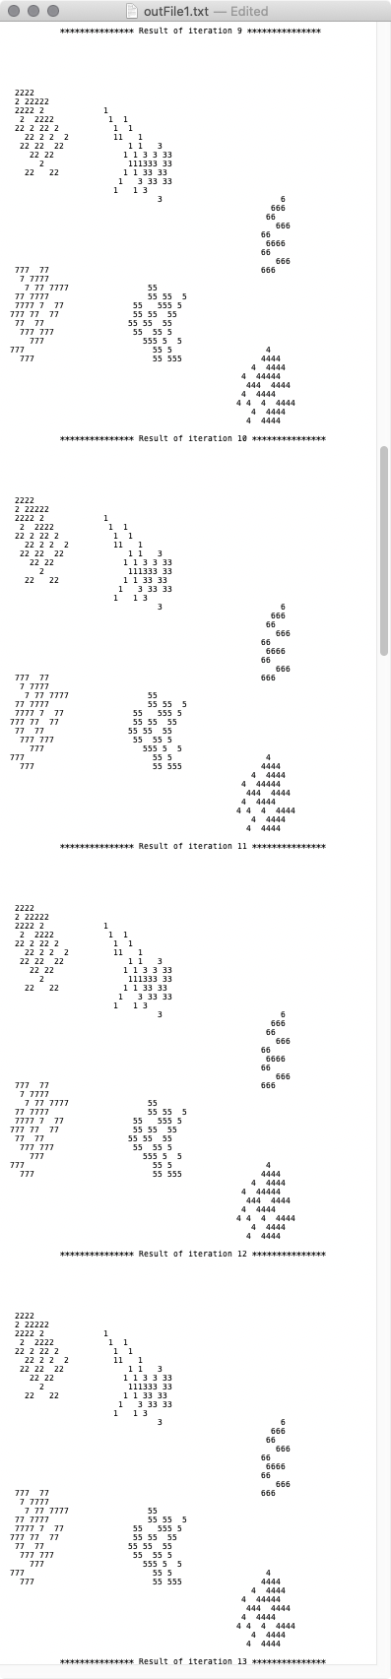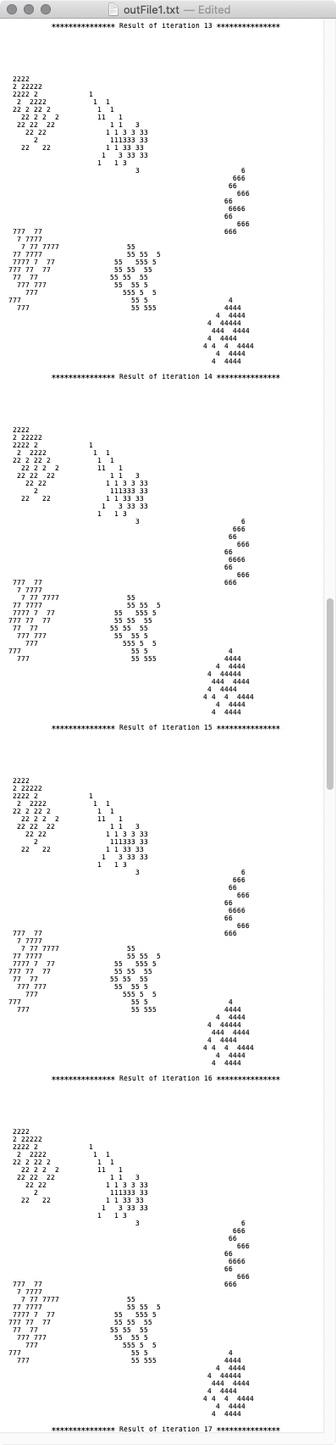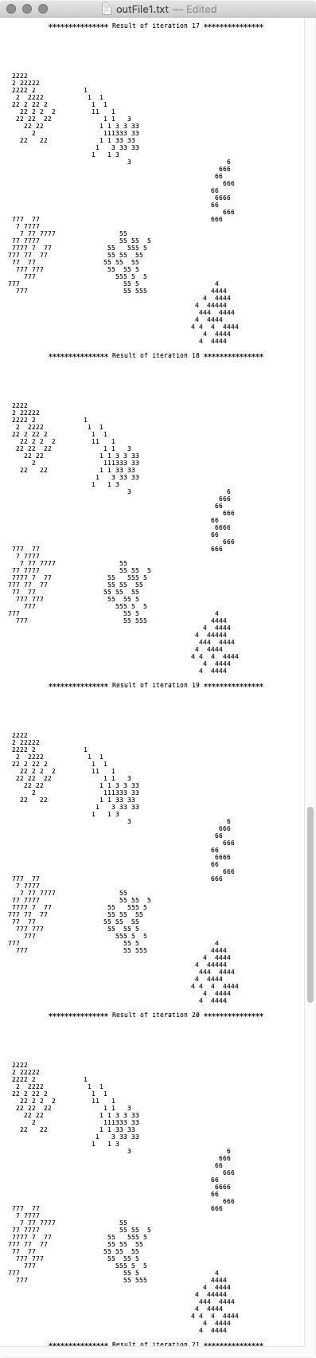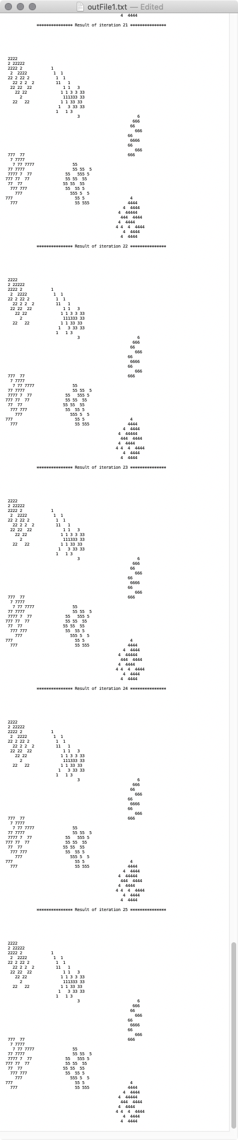

K = 7

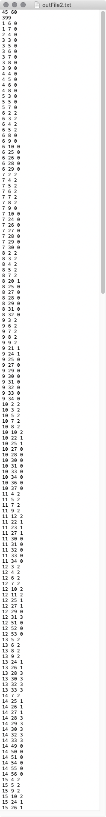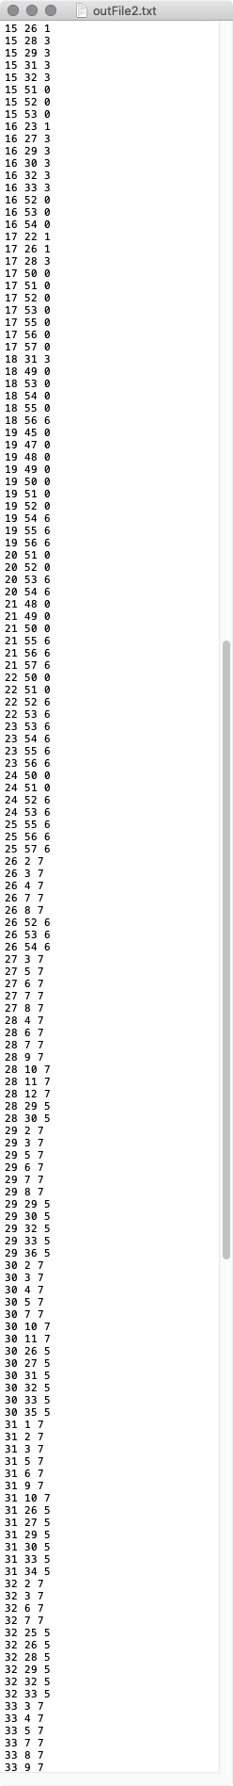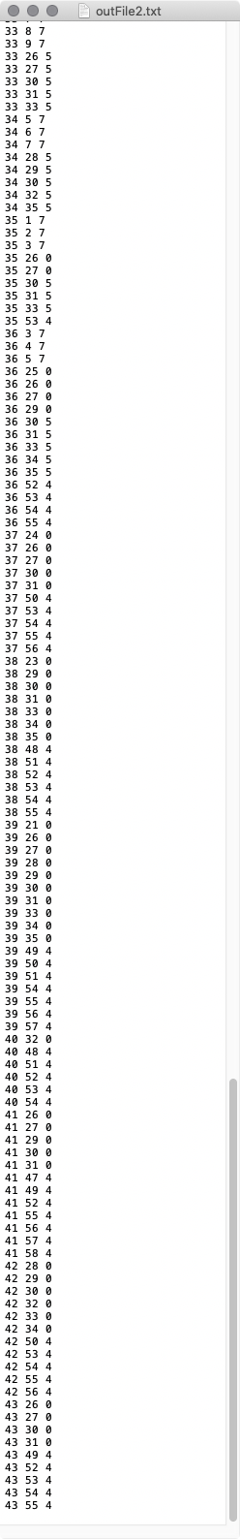

END OF K = 7